Elmgreen & Dragset at Frieze Sculpture 2025
Regent’s Park
17 September – 2 November 2025

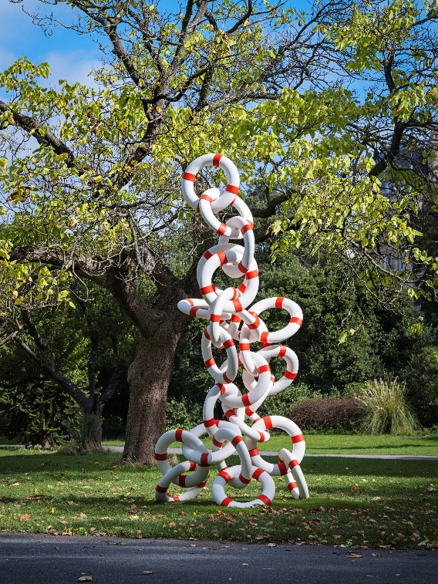

At the 2025 edition of Frieze Sculpture, Pace Gallery will present Elmgreen & Dragset’s Life Rings, Fig.3 (2023), a large-scale work that takes a typically singular, reusable, lightweight, and often weathered emergency tool and multiplies it into absurdity.

In this impossible-seeming tower configuration, the rings appear to have mushroomed upward toward the sky. Each ring is connected to the next, forming a structure that resembles a chain-link system.

Elmgreen & Dragset are known for making sculptures that transform everyday or inconspicuous objects in ways that shift their perceived value. Here, the life ring—usually made of basic materials like plastic or foam—is instead rendered in stainless steel, changing its materiality and thereby elevating it to a higher status associated with permanence, art, and architecture. The sculpture, climbing over four meters tall, becomes both a visual anchor and a potential meeting point.

Coinciding with Frieze Sculpture, the artists will also present an immersive installation titled The Audience in collaboration with Prada Mode at Town Hall, the recently restored landmark in King’s Cross, London. On view from October 15 – 19, Prada Mode London will feature talks, conversations, film screenings, performances, and DJ sets to further explore the idea of spectatorship and open up other ways of thinking about how audiences gather, watch, and respond.

At Pace’s Los Angeles gallery, the artists are presenting The Alice in Wonderland Syndrome, their first-ever solo exhibition in the city, on view through October 25. The show follows recent solo presentations at the Musée d’Orsay in Paris and the Amorepacific Museum of Art in Seoul and coincides with two milestones: the thirtieth anniversary of Elmgreen & Dragset’s artistic collaboration and the twentieth anniversary of their famed Prada Marfa installation, unveiled in Texas in 2005.
Pace is a leading international art gallery representing some of the most influential artists and estates of the 20th and 21st centuries, founded by Arne Glimcher in 1960. Holding decades-long relationships with Alexander Calder, Jean Dubuffet, Agnes Martin, Louise Nevelson, and Mark Rothko, Pace has a unique history that can be traced to its early support of artists central to the Abstract Expressionist and Light and Space movements. Now in its seventh decade, the gallery continues to nurture its longstanding relationships with its legacy artists and estates while also making an investment in the careers of contemporary artists, including Torkwase Dyson, Loie Hollowell, Robert Nava, Adam Pendleton, and Marina Perez Simão.

Under the current leadership of CEO Marc Glimcher and President Samanthe Rubell, Pace has established itself as a collaborative force in the art world, partnering with other galleries and nonprofit organizations around the world in recent years. The gallery advances its mission to support its artists and share their visionary work with audiences and collectors around the world through a robust global program anchored by its exhibitions of both 20th century and contemporary art and scholarly projects from its imprint Pace Publishing, which produces books introducing new voices to the art historical canon. This artist-first ethos also extends to public installations, philanthropic events, performances, and other interdisciplinary programming presented by Pace.

Today, Pace has eight locations worldwide, including two galleries in New York—its eight-story headquarters at 540 West 25th Street and an adjacent 8,000-square-foot exhibition space at 510 West 25th Street. The gallery’s history in the New York art world dates to 1963, when it opened its first space in the city on East 57th Street. A champion of Light and Space artists, Pace has also been active in California for some 60 years, opening its West Coast flagship in Los Angeles in 2022. The gallery maintains European footholds in London and Geneva as well as Berlin, where it established an office in 2023. Pace was one of the first international galleries to have a major presence in Asia, where it has been active since 2008, the year it first opened in Beijing’s vibrant 798 Art District. It now operates galleries in Hong Kong and Seoul and opened its first gallery in Japan in Tokyo’s Azabudai Hills development in 2024.

Elmgreen & Dragset, Life Rings, Fig. 3, 2023 © Elmgreen & Dragset, Artist Rights Society (ARS), New York

Press Inquiries

Europe
Rebecca Riegelhaupt
Senior Director, Communications
rriegelhaupt@pacegallery.com
+44 7917 909779

Kirsteen Cairns
Communications Manager
kcairns@pacegallery.com
+44 7467 830230

Sales Inquiries
Pace Gallery
londoninfo@pacegallery.com

Follow Pace Gallery
@pacegallery
@pacegallery
@pacegallery



